Practical 1 — GraphQL API using Express
Write a program to develop a basic GraphQL API using Node.js, Express, and GraphQL. Create a GraphQL schema for a collection of books and implement a query to retrieve all books.
Requirements:
- Create an Express server.
- Install and configure GraphQL libraries.
- Define a Book GraphQL type.
- Create a GraphQL schema.
- Implement a query named books.
- Return book ID, title, author, and price.
Hint:
Use:
Express
↓
GraphQL Middleware
↓
Schema
↓
Query
↓
Resolver
↓
Book Data
Important packages:
npm install express graphql express-graphql
CODE:
OUTPUT:
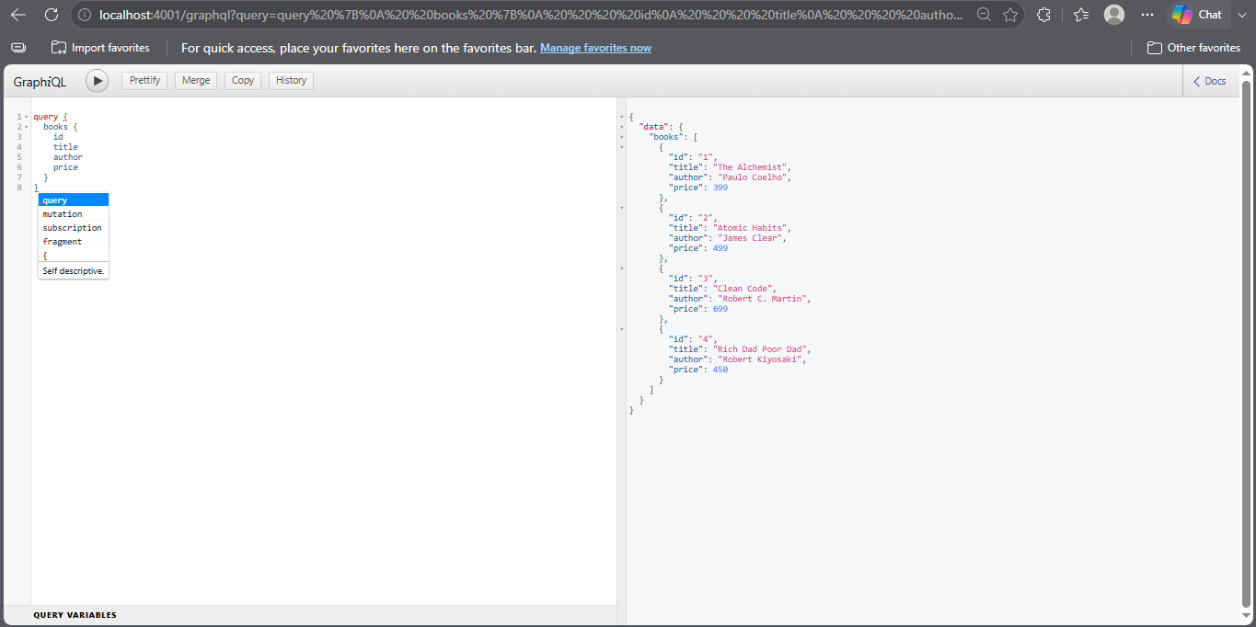
Practical 2 — Execute GraphQL Queries using GraphiQL
Write a program to develop a GraphQL API for student information and execute queries using the GraphiQL tool. The API should return student details based on the requested fields.
Requirements:
- Create a Student GraphQL type.
- Define fields such as id, name, course, and semester.
- Create a students query.
- Create a student(id: ID!) query.
- Test both queries using GraphiQL.
Hint:
Example GraphQL query:
query {
students {
id
name
course
semester
}
}
For a particular student:
query {
student(id: "1") {
name
course
}
}
Observe that GraphQL allows the client to request only the fields it requires.
CODE:
OUTPUT:
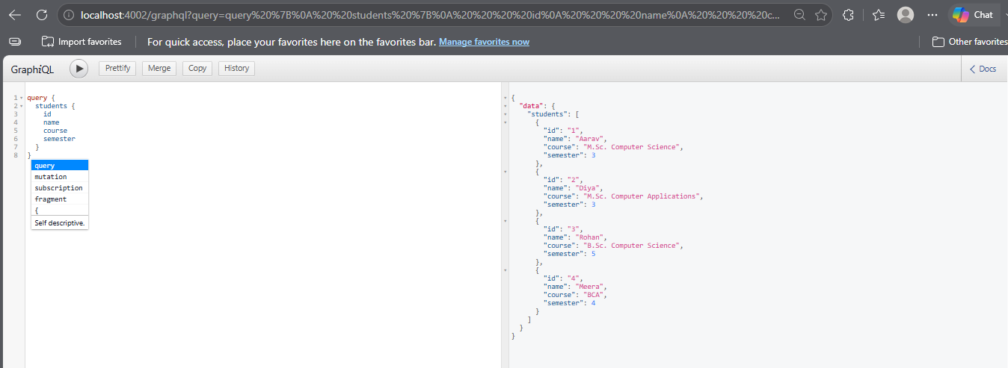
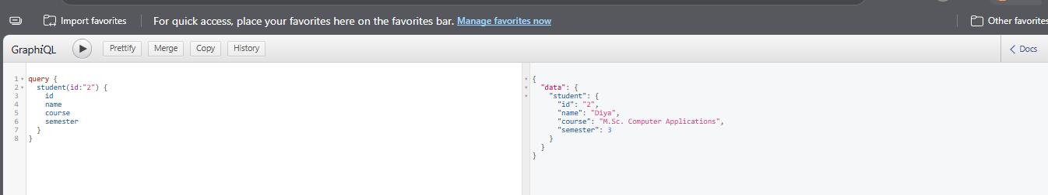

Practical 3 — GraphQL Mutations for a Product Application
Write a program to develop a GraphQL API for managing products. Implement GraphQL queries and mutations to add, update, and delete products.
Requirements:
- Create a Product type.
- Implement a query to retrieve all products.
- Implement a mutation to add a product.
- Implement a mutation to delete a product.
- Test the queries and mutations using GraphiQL.
Hint:
Define mutations similar to:
type Mutation {
addProduct(
name: String!
price: Float!
): Product

deleteProduct(id: ID!): Boolean
}
CODE:
OUTPUT:
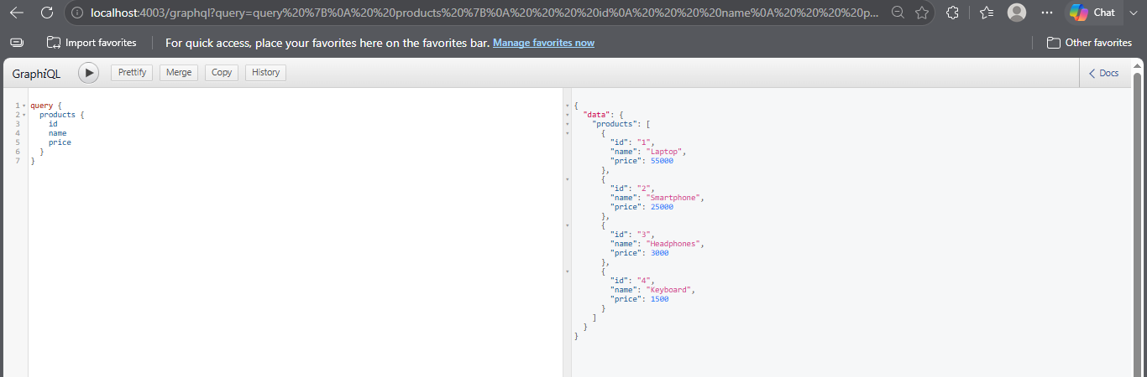
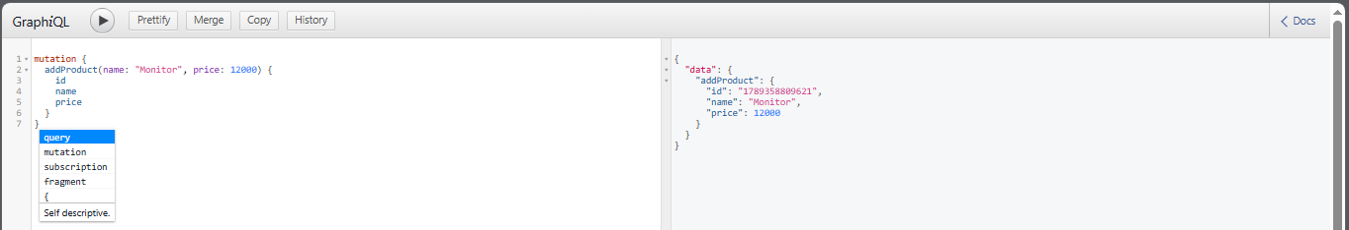
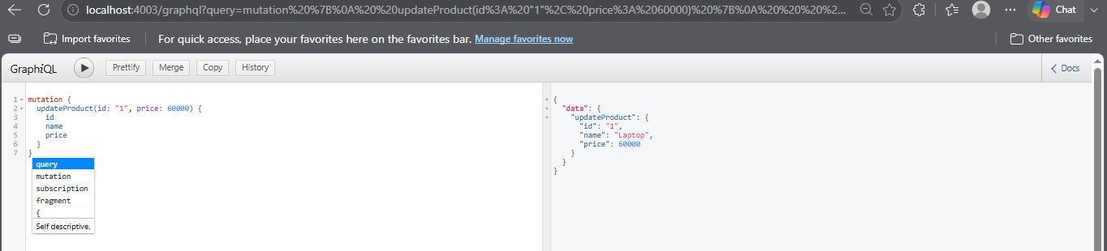
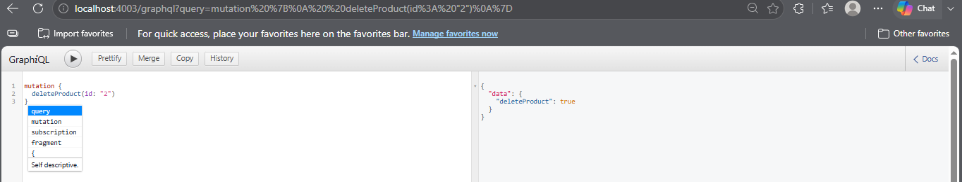
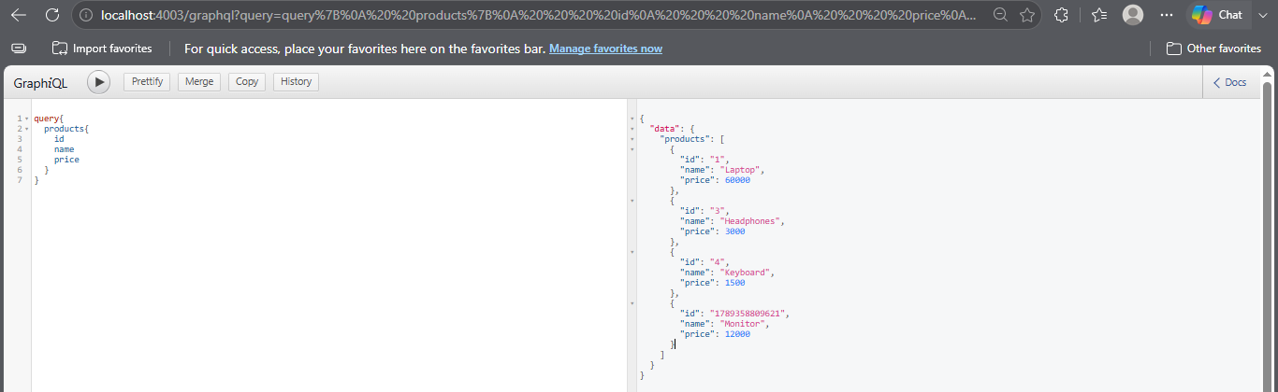
Practical 4 — Space Launch Application using Apollo Client
Write a React JS program to develop a Space Launch Application using Apollo Client and GraphQL. Fetch space launch information from a GraphQL API and display the launch details.
Requirements:
- Create a React application.
- Install Apollo Client and GraphQL.
- Configure ApolloClient.
- Create a GraphQL query for launch information.
- Use useQuery() to execute the query.
- Display loading, error, and successful results.
Hint:
Install:
npm install @apollo/client graphql
Basic Apollo setup:
const client = new ApolloClient({
uri: "GRAPHQL_API_URL",
cache: new InMemoryCache()
});
Use:
const { loading, error, data } = useQuery(QUERY);
CODE:
OUTPUT:
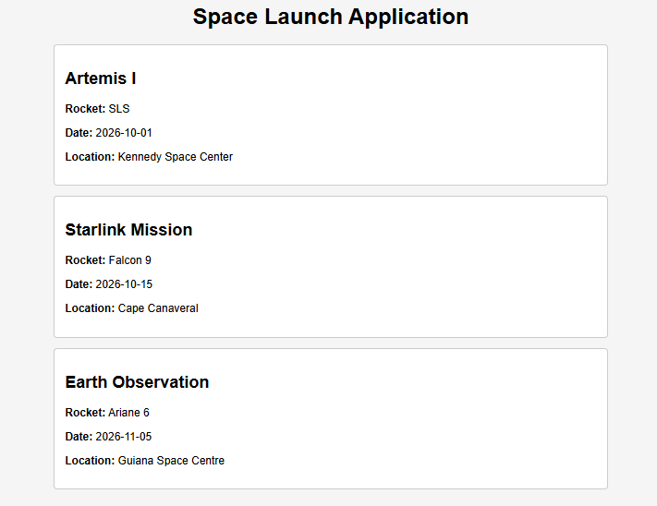

Practical 5 — GraphQL CRUD Application using React and Apollo Client
Write a React JS program to develop a Product Management Application using GraphQL and Apollo Client. The application should display products and allow the user to add a new product.
Requirements:
- Configure Apollo Client.
- Create a product query.
- Display products using useQuery().
- Create an addProduct mutation.
- Use useMutation() from Apollo Client.
- Update the displayed product list after adding a product.
Hint:
Use:
const { data, loading, error } = useQuery(GET_PRODUCTS);
and:
const [addProduct] = useMutation(ADD_PRODUCT);
After a successful mutation, refresh the query or update Apollo's cache.
CODE:
OUTPUT:
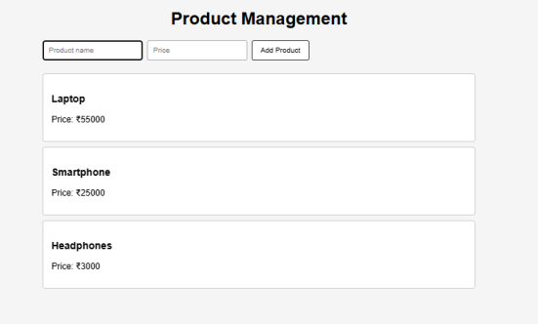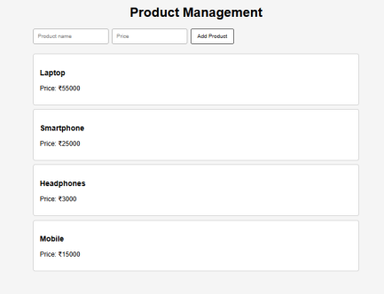

Practical 6 — Jest Unit Testing for Redux Reducer
Write a program to create a Jest testing application and test a Redux reducer. Test the reducer for initial state, increment, decrement, and reset operations.
Requirements:
- Create a simple Redux counter reducer.
- Configure Jest.
- Write test cases using describe() and test().
- Test different Redux actions.
- Verify the expected state using expect().
Hint:
Basic Jest syntax:
describe("Counter Reducer", () => {
test("should increment", () => {
expect(actual).toEqual(expected);
});
});
Test at least:
Initial State
Increment
Decrement
Reset
CODE:
OUTPUT:
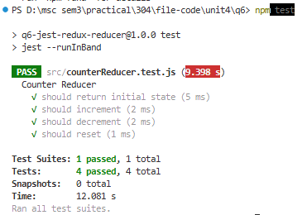
Practical 7 — Jest Component and Snapshot Testing
Write a React JS program to create a simple Student/Product component and perform unit testing and snapshot testing using Jest and React Testing Library.
Requirements:
- Create a React component.
- Display student/product information.
- Test whether the component renders correctly.
- Test whether important text is displayed.
- Create a snapshot test.
- Run all tests using Jest.
Hint:
Install:
npm install -D jest @testing-library/react @testing-library/jest-dom
Useful methods:
render()
screen.getByText()
expect()
toMatchSnapshot()
Snapshot example:
const { container } = render(<Student />);
expect(container).toMatchSnapshot();
CODE:
OUTPUT:
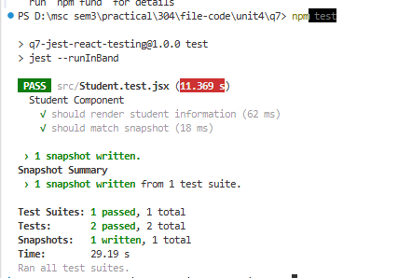
Practical 8 — Dockerize and Deploy a React Application using Nginx
Write a program to deploy a React JS application using Nginx and Docker. Build the React application, configure Nginx as a web server, create a Docker image, and run the application inside a Docker container.
Requirements:
- Create a production build of the React application.
- Create a Dockerfile.
- Use Nginx as the production web server.
- Build a Docker image.
- Run the Docker container.
- Access the React application through the browser.
Hint:
The deployment flow is:
React Source Code
↓
npm run build
↓
Production Build
↓
Nginx
↓
Docker Image
↓
Docker Container
↓
Browser
Important Docker commands:
docker build -t react-app .
docker run -p 8080:80 react-app

